

COMP C 28 CHANDRABHAN SINGH

EXPERIMENT NO. 6

**Aim:** To demonstrate data structure in python (list, tuple, vectors, dictionary, dataframes)

**Theory:**

**List:** The list is a most versatile datatype available in Python which can be written as a list of comma-separated values (items) between square brackets. Important thing about a list is that items in a list need not be of the same type.

**Tuple:** A tuple is a sequence of immutable Python objects. Tuples are sequences, just like lists. The differences between tuples and lists are, the tuples cannot be changed unlike lists and tuples use parentheses, whereas lists use square brackets.

Creating a tuple is as simple as putting different comma-separated values. Optionally you can put these comma-separated values between parentheses also.

**Vectors**: A vector is known as a single dimension-array. In python, vector is a **single one-dimension** array of lists and behaves same as a Python list. According to a Google, vector represents direction as well as magnitude; especially it determines the position one point in a space relative to another.

**Dictionary:** In Dictionary each key is separated from its value by a colon (:), the items are separated by commas, and the whole thing is enclosed in curly braces. An empty dictionary without any items is written with just two curly braces, like this − {}.

Keys are unique within a dictionary while values may not be. The values of a dictionary can be of any type, but the keys must be of an immutable data type such as strings, numbers, or tuples.

**Dataframes:** A Pandas DataFrame is a 2 dimensional data structure, like a 2 dimensional array, or a table with rows and columns.

**Implementation:**

List:

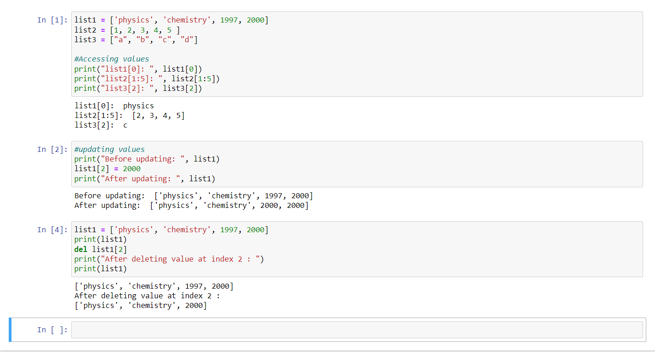

Tuple:

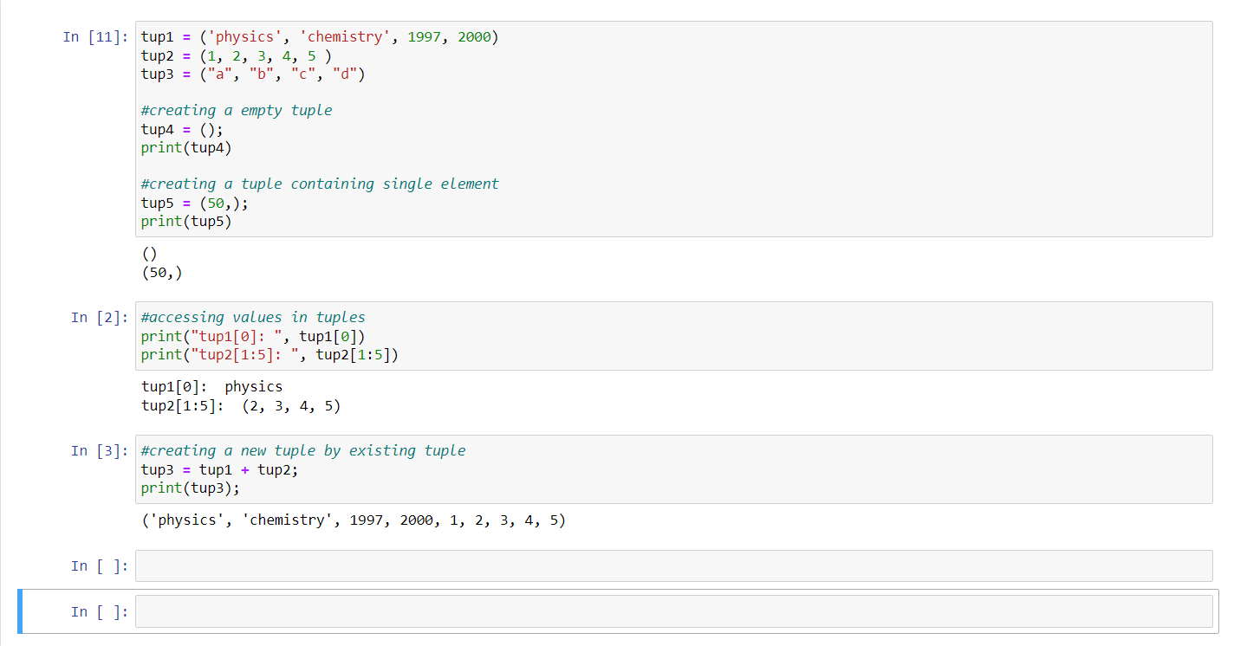

Vectors:

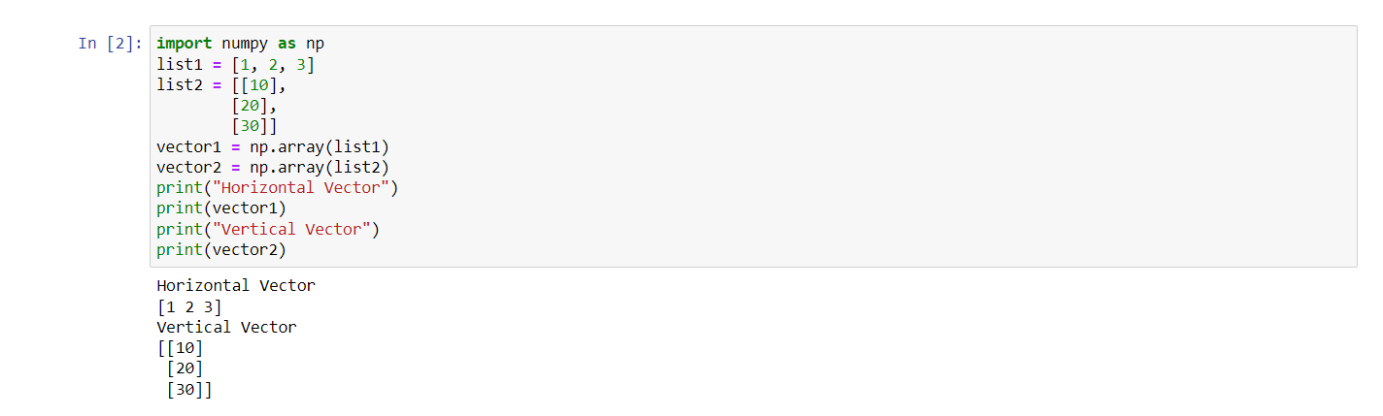

Dictionary:

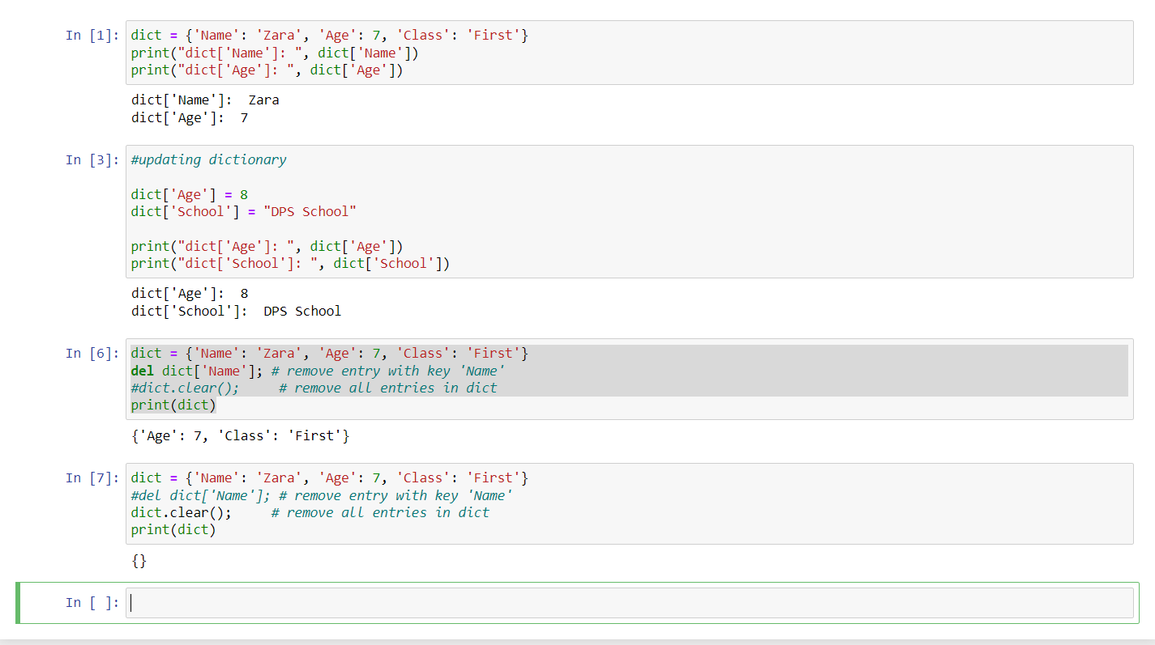

Dataframes:

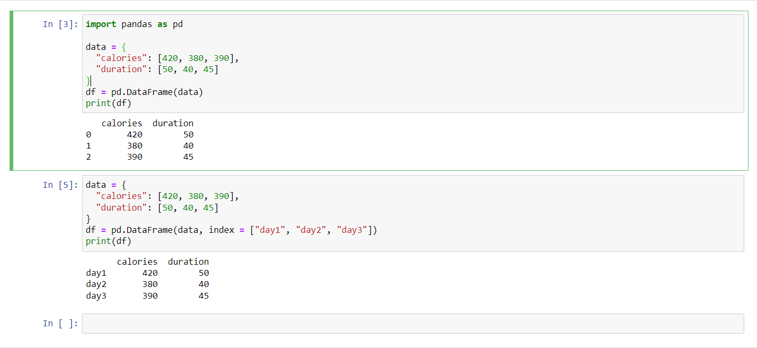

**Conclusion:**

1. We learned about the data structures of python like list, tuples, dictionary.
2. We also learned about the dataframes and how to declare the vector in python.
3. After this experiment students can perform the function on the data structures, vectors and dataframes by using panda.